BUSINESS UNIT PERFECT CHARGING

Press release

Fronius Charge & Connect: smart network solution for battery chargers

Greater transparency and lower costs

Wels, DD/03/2020 – Digital networking is taking great leaps forward in intralogistics, including in the operation of electric forklift trucks. With Charge & Connect, Fronius Perfect Charging has launched a solution which allows the company’s battery chargers to be connected as part of a smart network. Users benefit from greater transparency and a better overview when charging their traction batteries, plus load spikes can be reduced.

In the past, forklift truck operators have found it difficult to centrally monitor and control the charging processes for their traction batteries. With Charge & Connect, Austrian battery charging solutions expert Fronius has created a new digital solution for networking its Selectiva chargers. Charging station data is displayed on the dashboard, giving a wealth of new options for users to further increase efficiency and performance in their company.

Cross-location, central overview
With Charge & Connect, information such as the energy consumption of each charging process and the status of the charger is displayed transparently. The user benefits from a central overview across several locations and can promptly and quickly counteract potential operating and application errors. Extensive analysis functions make it possible to easily identify where charging processes can be improved.

Always up-to-date
If a fault occurs in the charging technology, the system automatically sends a notification to the contact saved in the system. This means that problems and application errors can be remedied quickly before they result in expensive downtime or lifecycle costs.

Reduced load spikes
Another advantage is that chargers can be controlled centrally. For instance, fleet operators have the option to coordinate the charging of their various forklift trucks – for example to avoid peak currents and therefore reduce their ongoing energy costs. Charging times can be extended in line with the relevant requirements in order to better manage the capacity of the battery pool and therefore minimise costs and risks of downtimes.

2,168 characters incl. spaces

Meta title: Fronius Charge & Connect: digital network solution for battery chargers

Meta description: With the Charge & Connect smart networking solution, Fronius is increasing transparency in the charging infrastructure.

Keywords: Fronius; Perfect Charging; Charge & Connect; battery charging technology; chargers; network; networking, digital; smart; transparency; control; monitoring; analysis

Image captions:

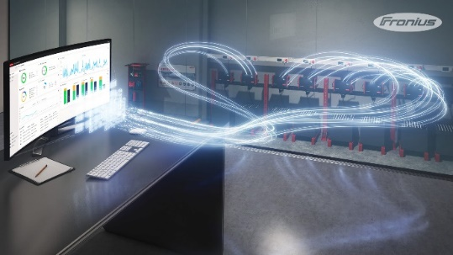
Image 1: With Charge & Connect, Fronius Perfect Charging is launching a solution that can be used to intelligently network the manufacturer’s battery charging systems together.

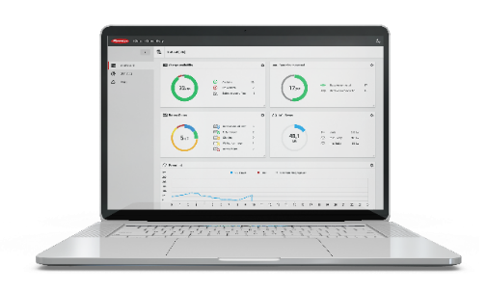
Image 2: Among other things, Charge & Connect allows the energy consumption of each charging process and the status of the charger to be displayed transparently.

Copyright to photos: Fronius International GmbH, reproduction free of charge
The high-resolution pictures are available for download here.

Contact details for this publication:
Company name: | Fronius Perfect Charging
E-mail: | perfect.charging@fronius.com
Website: | www.fronius.com/intralogistics
YouTube: | www.youtube.com/FroniusCharging
LinkedIn: | www.linkedin.com/showcase/perfect-charging
Phone International: | +43 7242 2410
Phone UK & Ireland: | +44 1908 512300
Phone India: | +91 97654 98881

For more exciting updates, follow us on LinkedIn (perfect-charging)
and YouTube (FroniusCharging)!

Fronius International GmbH
Fronius International GmbH is an Austrian company with headquarters in Pettenbach and other sites in Wels, Thalheim, Steinhaus and Sattledt. With 4,760 employees worldwide, the company is active in the fields of welding technology, photovoltaics and battery charging technology. 92% of its products are exported through 30 international Fronius subsidiaries and sales partners/representatives in over 60 countries. With its innovative products and services and 1,253 granted patents, Fronius is the global innovation leader.

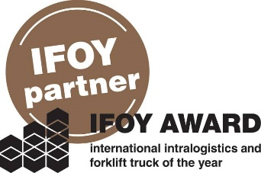 | Fronius is an official partner of the annual IFOY AWARD (International Intralogistics and Forklift Truck of the Year), which recognises the best forklift trucks and application solutions in the industry, trade and service sectors.

For more information, please contact:
Fronius International GmbH
MMag. Sonja POINTNER, +43 (7242) 241-6436, pointner.sonja@fronius.com
Fronius International GmbH, Froniusplatz 1, 4600 Wels, AUSTRIA

Please send an author's copy to our agent:
a1kommunikation Schweizer GmbH, Mrs. Kirsten Ludwig,
Oberdorfstraße 31 A, 70794 Filderstadt, GERMANY,
Tel.: +49 (0)711 9454161-20, e-mail: Kirsten.Ludwig@a1kommunikation.de

