TECHNICAL REPORT

Assistance systems for robotic welding:

Support for automated series production

Automated welding, completely autonomous, with flawless weld seams – this is our vision. Air gaps, clamping tolerances, and other imperfections would become a thing of the past or would be automatically compensated for by the robot welding system. This may still be a long way off in some respects, and yet numerous robotic assistance systems are already helping to reduce manual intervention in automated series production. With WireSense, SeamTracking, TouchSense, and TeachMode, Fronius has a wide-ranging high-tech portfolio to suit various different applications.

Author: Andreas Hummelbrunner, Product Line Manager MIG/MAG High End Robotics, R&D Fronius International GmbH

There are a number of different systems which assist with automated robotic welding. They all have a common aim – prevent cycle time losses and ensure reliable seam quality. Sensors play a central role here; lasers, cameras, or even tactile sensors are designed to detect whether the component is in the right location and whether there are any air gaps present. You can also define how the system responds. However, this additional hardware goes hand in hand with huge expense during installation and operation – and investment costs are often high.

What is more, while many of these systems do increase seam quality, they result in cycle time losses. Their interference contours often also restrict component accessibility, which is why Fronius offers an alternative which can tackle these challenges: high-precision control of the welding wire, combined with the rapid data transfer of the TPS/i power source, means that the wire can also be used as a sensor as well as a filler metal – an approach which opens up completely new possibilities.

Detect edge positions and air gap heights with WireSense

The patented WireSense technology works together with the welding system to enable the robot to detect the edge position and any air gaps between the sheets. To do so, the wire electrode becomes a height sensor. During the WireSense scanning process, the robot first makes its way to the required position. The welding wire, to which a low sensor voltage is supplied, scans the component with reversing wire movements in the range of one hundred Hertz. If the wire touches the component, it results in an imperceptible short circuit. The short circuit is then cleared by raising the wire.

The TPS/i power source analyses the change in the position of the welding wire at the instant of the short circuit and makes it available to the robot as a height signal. Together with the positional data from the robot controller and a reference point defined at the outset, WireSense allows each geometrical change on the component to be registered with precision. If the robot and WireSense were to be moved over the workpiece along an infinite series of sequential paths, recording every point in the process, it would theoretically be possible to construct the complete 3D component contour.

In practice, the most important applications of this sensor system are edge and height detection, such as for lap joints. A defined threshold, which lies somewhat below the sheet edge height, is determined in advance. Should the power source detect values that lie above this threshold during the WireSense scanning process, this indicates that the edge of the sheet has been detected and the TPS/i immediately outputs a digital touch signal and the determined height value. As a result, the robot knows where the edge of the sheet is and how high it is.

Edge detection: correcting the robot path

The robot controller can use this signal to save its current positional data and then correct the robot path by comparing it with the target data. Any component inaccuracies are thus recognized and compensated for. The robot then welds in exactly the right location. Edge detection is already possible for material thicknesses of 0.5 mm and above and sheet thicknesses of up to 20 mm.

Height measurement: reliable welding despite air gap

As the precisely measured sheet edge height is also transmitted with the digital touch signal, WireSense enables any air gaps between the sheets to be calculated. Assuming they have been specified in advance, the various welding programs – or jobs – stored in the TPS/i can be called up as required for the various air gaps. As a result, the robot can respond appropriately and weld with the welding parameters that are ideal for the air gap dimension in question.

Thus WireSense helps with tolerance fluctuations in the components for welding and also counters tolerances in the clamping technology. The assistance system ensures reliable seam quality and reduced rework and component rejects by up to 100 percent – without any additional sensor hardware. To achieve this, the Fronius welding system simply needs to be equipped with a CMT-ready system, to ensure high-precision control of the welding wire.

Quick robot programming with TeachMode

The robot path must be manually programmed before welding can begin – this is called the teach process. It involves the welder or programmer using a teach pendant to control the robot, scan the component, and save the positional data. In terms of the quality of the weld seam, it is important that a constant distance is maintained between the component and the contact tip across the entire weld seam – this is called the stick out. Assistance systems can also help with this time-consuming, manual process.

TeachMode from Fronius uses a reversing wire movement to prevent the welding wire from being bent when scanning the component. The reversing wire movement begins as soon as the pre-set stick out is undershot by the robot. At the same time, a visual/audible signal informs the user that they must move the welding torch away from the component. This saves the user from having to remove the deformed wire or re-measure the stick out, and speeds up the teach process by up to 30 percent.

SeamTracking: seam tracking during welding

The Fronius SeamTracking assistance system is of particular use in the manufacture of railway or construction vehicles. Where thick sheets or long seams are being welded, the resulting heat can result in distortion or poor positioning of the components. To ensure the robot welds in the right location, a system is needed which reliably detects the welding position during welding. SeamTracking does just that for fillet welds and prepared butt welds – without any additional sensor hardware whatsoever.

To do so, the robot moves back and forth between the two sheets during welding. The robot uses the measured actual values for the individual welding parameters to detect the actual welding position or any deviations. The pre-programmed path is automatically corrected and the robot welds reliably in the correct position.

Detecting a fillet weld position with TouchSense

To compensate for component and clamping tolerances, the robot can use TouchSense to check the position of fillet welds automatically before each weld. To do so, the robot touches the two sheets with the wire electrode or the gas nozzle – which are supplied with a low sensor voltage – at the defined beginning and at the end of the weld seam. The signals contained in the short circuit enable the perfect starting point to be determined.

Save money with wire-based assistance systems

In all, the Fronius robot assistance systems enable more efficient and more reliable robotic welding processes. Rework on components can be significantly reduced and the time and effort spent on subsequent re-programming of robot paths decreases as the robot can correct the weld seam path by itself, all of which reduces production costs. With the Fronius assistance systems, the wire electrode doubles as a sensor as well as filler metal. This saves users money and time spent on maintenance for sensor hardware and does not restrict component accessibility in any way.

7,980 characters (including spaces)

[Navigation Title]
Robotic welding: Assistance systems

[Display Name: URL]
robotic-welding-assistance-systems

[Meta-Title]
Assistance systems for welding with robots

[Meta-Description]
Reduce the need for intervention in automated series production: assistance systems such as WireSense and TeachMode from Fronius help with robotic welding.

Image captions:

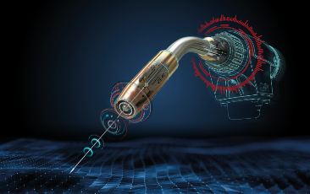
Image 1: The wire becomes a sensor with the new assistance systems for robotic welding from Fronius.

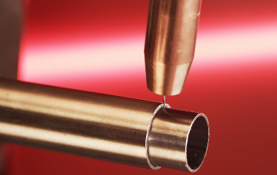
Image 2: With WireSense, the wire electrode scans the component and detects the edge position and height on both sheets and pipes.

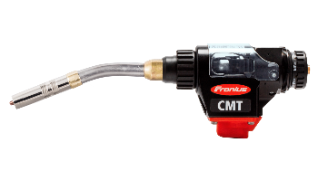
Image 3: The highly dynamic and precise wire movement of the Robacta Drive CMT drive unit makes it possible to scan the components using the wire electrode.

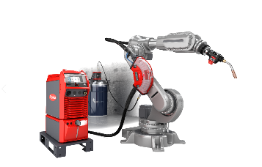
Image 4: WireSense can be used with every TPS/i welding system from Fronius that is equipped with hardware for the CMT welding process.

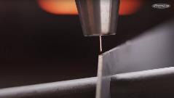
Image 5: TeachMode from Fronius helps users program the robot path and makes the process more efficient.

Videos:

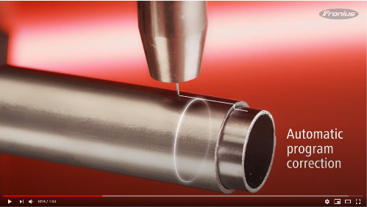
WireSense video: https://www.youtube.com/watch?v=C0YawfPs_Tk

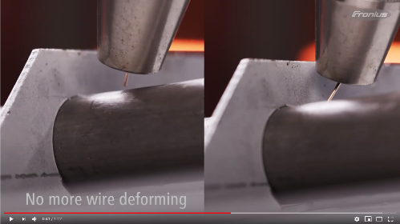
TeachMode video: https://www.youtube.com/watch?v=95zvimzn0s0

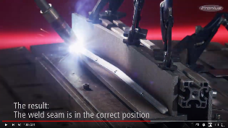
TouchSense & SeamTracking video: https://www.youtube.com/watch?v=16rglvD8qLc&t=3s

Photos: Fronius International GmbH, reproduction free of charge

This news release and the images can be downloaded from:
https://www.fronius.com/en/welding-technology/info-centre/press/robotic-welding-assistance-systems

Business Unit Perfect Welding
Fronius Perfect Welding is the innovation leader for arc welding and is the global market leader for robot assisted welding. As system providers, Fronius Welding Automation also turns customer-specific automated complete welding solutions into reality in a number of areas, from container construction right up to cladding for the offshore sector. Power sources for manual applications, welding accessories and a wide range of services add to our portfolio. With more than 1,000 sales partners worldwide, Fronius Perfect Welding is never far away from our customers.

Fronius International GmbH
Fronius International is an Austrian company with headquarters in Pettenbach and other sites in Wels, Thalheim, Steinhaus and Sattledt. Founded by Günter Fronius in 1945, this long-standing company with a rich tradition will be celebrating its 75th anniversary in 2020. What began as a local one-man venture has grown into a global player with more than 5440 employees worldwide working in the areas of welding technology, photovoltaics and battery charging systems. Its export ratio of around 93 percent is achieved with 34 international Fronius subsidiaries and sales partners/representatives in more than 60 countries. Moreover, its innovative products and services and its portfolio of 1264 registered patents make it an innovation leader on the world market.

For more information, please contact:
Fronius USA LLC, Ms. Welch Stephanie,
6797 Fronius Drive, 46368 Portage, IN
Tel: +1 (219) 734 5701, E-Mail: welch.stephanie@fronius.com

Please send an author's copy to our agent:
a1kommunikation Schweizer GmbH, FAO Kirsten Ludwig,
Oberdorfstraße 31 A, 70794 Filderstadt, Germany,
Tel.: +49 (0)711 9454161-20, e-mail: Kirsten.Ludwig@a1kommunikation.de

For more exciting updates, visit our blog at blog.perfectwelding.fronius.com and follow us on Facebook (froniuswelding), Twitter (froniusintweld), LinkedIn (perfect-welding), Instagram (froniuswelding) and YouTube (froniuswelding)!

