NEWS RELEASE

Digitalization in Automotive Engineering
“Joining Smart Technologies” automotive conference at Fronius

On May 8 and 9, Fronius hosted the sixth international automotive conference in Sattledt, Upper Austria. Alongside automotive engineering experts, the speakers included luminaries from the area of digitalization, all of whom made the future of automotive manufacture in the digital revolution more tangible for those in attendance.

Digitalization was the central topic for this year’s “Joining Smart Technologies” conference. Over a hundred delegates from ten countries used the conference to exchange their knowledge and experiences and appeared inspired by the high-quality presentations and networking opportunities.

Standardization and Personalization

At the start of the conference, Thomas Bauernhansl, Head of the Fraunhofer Institute for Manufacturing Engineering and Automation, gave his insights into the current state of automotive engineering within the digital revolution. His central theme was: Data in the factory of tomorrow. Data will play a key role, whether for standardized products or mass-produced products in the future, driverless taxis, or heavily customized cars for end customers. In relation to this, Bauernhansl primarily appealed directly to the conscience of businesses: “For machine learning, data is the raw material used to generate machine algorithms. The data quality therefore plays a decisive role for the entire process.”

The Smart Arc

Christian Kotschote, Technology Developer at Audi, reported on the potential for connectivity in the area of thermal welding, underlining that digital systems have the potential to increase the output of arc applications. To do so, all information needs to be made usable right along the entire process chain, including the steps before and after welding.

Following on from this point, Helmut Ennsbrunner, Head of Pre-Development at Fronius, set out what the digital transformation means from the perspective of a welding systems manufacturer. Ennsbrunner explained that digitalization enables data to be reproduced without loss and exchanged with partners. This opens up new opportunities for collaboration: on one hand, automated machines should be able to work together more efficiently; on the other, information can be shared between suppliers, customers, and other partners, and used for new cooperative business models.

Teamwork with Robots

Martina Mara’s presentation also focused on cooperation: as a tech psychologist and Professor of Robopsychology at Johannes Kepler University Linz Martina works predominantly with cooperation between humans and robots. At the automotive conference, she stressed that being able to predict how machines will interact with humans is crucial in determining how efficiently human-machine teams will work together.

In the panel discussion that followed, Florian Oefele, Senior Manager Virtual Commissioning and Digitalization Assembly at BMW, also placed humans at the centre of the digital revolution. Only openness, trust, and responsibility can enable us to exploit the opportunities offered by digitalization. Michael Zürn, Senior Manager Process Engineering at Daimler, specified precisely where these opportunities lie: “Data helps us humans to master complexity and therefore to make better decisions more easily.” In the industrial environment this helps shorten production times and optimize costs and quality. Furthermore, representatives of the OEMs took a look into the future and agreed that sustainability is gaining in significance. In the future, digital solutions like blockchain could also help to bring transparency to quality in terms of social aspects and sustainability.

3,705 characters (including spaces)

Captions:

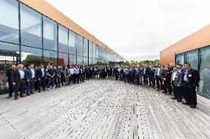
Image 1: Around 100 attendees who took part in the 2019 automotive conference at Fronius’ Sattledt location

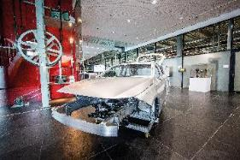
Image 2: The “Joining Smart Technologies” conference is dedicated to joining technology in automotive engineering

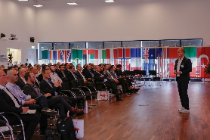
Image 3: Thomas Bauernhansl, Head of the Fraunhofer Institute for Manufacturing Engineering and Automation, appealed to businesses to see data as a vital raw material

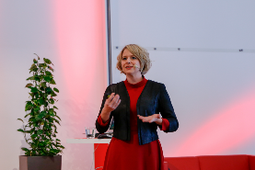
Image 4: Martina Mara from JKU Linz is researching how robots should be designed and how they need to behave in order for them to work with humans as smoothly as possible

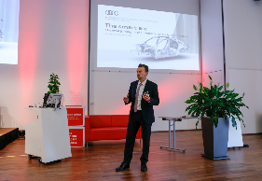
Image 5: Christian Kotschote from Audi pointed out that connectivity in production can increase the output of welding processes

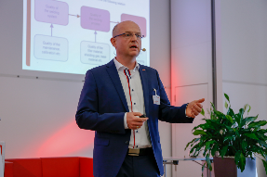
Image 6: According to Helmut Ennsbrunner of Fronius, digitalization is opening up a whole range of possibilities in terms of collaboration – both between machines and between human partners

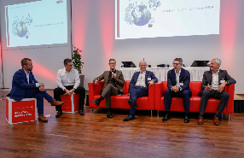
Image 7: At the panel discussion, the conference leaders pointed out that the digital systems of the future should not only be able to support technical quality but also sustainable solutions

Copyright to photos: Fronius International GmbH, reproduction free of charge

High-resolution images are available to download at the following link:
www.fronius.com/en/welding-technology/infocentre/press

Business Unit Perfect Welding
Fronius Perfect Welding is an innovation leader for arc and resistance spot welding and a global market leader for robot-assisted welding. As a systems provider, the Fronius Welding Automation division also implements customized automated complete welding solutions, for the construction of containers or offshore cladding for example. The range is rounded off by power sources for manual applications, welding accessories, and a broad spectrum of services. With more than 1000 sales partners worldwide, Fronius Perfect Welding has great customer proximity.

Fronius International GmbH
Fronius International GmbH is an Austrian company with headquarters in Pettenbach and other sites in Wels, Thalheim, Steinhaus and Sattledt. With 4,760 employees worldwide, the company is active in the fields of welding technology, photovoltaics and battery charging technology. 92% of its products are exported through 30 international Fronius subsidiaries and sales partners/representatives in over 60 countries. With its innovative products and services and 1,253 granted patents, Fronius is the global innovation leader.

Contact details for publishing:
Fronius UK Ltd
+44 1908 512300
info-uk@fronius.com
www.fronius.co.uk

For more information, please contact:
Fronius UK Ltd ; Miss Kim Wharton;
Maidstone Road, Kingston, Milton Keynes, MK10 0BD
Phone: +44 1908 512340
E-Mail: wharton.kim@fronius.com

Please send a specimen copy to our agency:
a1kommunikation Schweizer GmbH, Kirsten Ludwig,
Oberdorfstraße 31 A, D – 70794 Filderstadt, Germany
Phone: +49 (0)711 9454161-20
E-Mail: Kirsten.Ludwig@a1kommunikation.de

For more exciting updates, visit our blog at blog.perfectwelding.fronius.com and follow us on Facebook (froniuswelding), Twitter (froniusintweld), LinkedIn (perfect-welding), Instagram (froniuswelding) and YouTube (froniuswelding)!

