News release
Perfect Welding

Fronius TIG DynamicWire

Cold wire TIG welding – smart and simple
TIG cold-wire components are available now for Fronius iWave. The pioneering innovation lies in its intelligent control. With the patented new TIG DynamicWire welding package, even amateurs can achieve perfect TIG welds with ease. This is because the dynamic wire control always selects the right travel speed. The process adapts to the welder, not the other way around!
TIG welding represents the top tier of welding processes and demands skill as well as years of practice – or does it? “All the new features that we’ve packed into the iWave cold-wire components as well as the corresponding software solution make TIG welding significantly easier,” explains Manuel Rumpl, Head of Strategic Product Management Industrial Welding Solutions, Fronius International GmbH. “Thanks to TIG DynamicWire, welders can focus all their attention on the arc and the welding system regulates the optimal wire speed at all times.”
The iWave power categories from 300i to 500i can be upgraded to the TIG cold-wire system. The TIG DynamicWire welding package is ready for use immediately by means of software activation and can also be retrofitted to existing iWave systems at any time.
Market innovation: active wire control
The innovative advantage of Fronius DynamicWire compared to a conventional continuous wire feed lies in its automatic self-regulation. The welding system actively adjusts the wire speed to the welding behavior, torch position, and current conditions, even automatically compensating for component tolerances of up to 30%. The result? Perfect welds every time.
Precise and user-friendly
During development of the cold-wire system, no detail was too small for Fronius when it came to ensuring that welders could work optimally with minimal steps and adjustments. The wirefeeder is set once and then remains in a stable position. The ergonomic and flexible tungsten holder is particularly lightweight as it is produced using material-saving aluminum 3D printing. There are also no disturbing vibrations at the torch handle, as – unlike with comparable solutions – the mechanical forward and backward motion of the wire has been dispensed with entirely with the new TIG DynamicWire cold-wire welding process.
Change the tungsten electrode at the touch of a button
With the Tungsten Fast Clamp system (TFC), welding expert Fronius is bringing out another new patent. A single touch of the button releases and clamps the tungsten electrode in the spring-loaded clamping sleeve. Like the lead of a mechanical pencil, the electrode is changed in a matter of seconds. This system can now also be mounted on existing torch bodies.

Self-regulating, time-saving, and resource-conserving
In times of skills shortages, iWave complete with cold-wirefeeding and TIG DynamicWire can help all TIG novices and those with less experience achieve a great welding result and fast. Self-regulating parameter settings and characteristics as well as a compensatory active wirefeeder provide the necessary safety and ensure a high level of quality.
Since the wire does not continuously move back and forth during intelligent TIG cold-wire welding, even wear parts such as the torch body, torch cap, and clamping sleeve experience reduced abrasion and last longer than comparable solutions.
Find more on this at:
TIG DynamicWire

This press release, and the pictures, are available for download from: https://www.fronius.com/en/welding-technology/info-centre/press

2,855 characters (including spaces)

Images
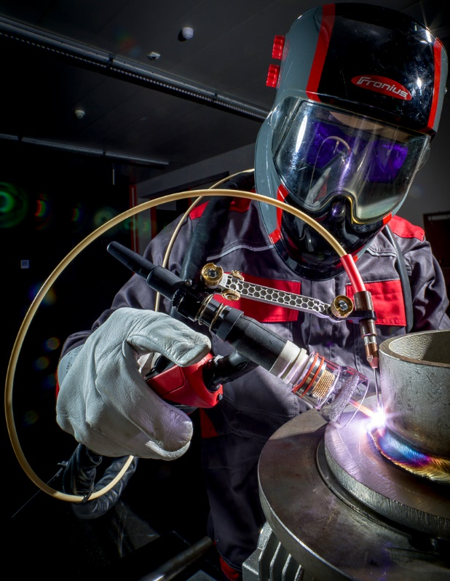
The new Fronius cold-wire components for iWave are lightweight and ergonomic, providing a lot more flexibility for TIG welding.

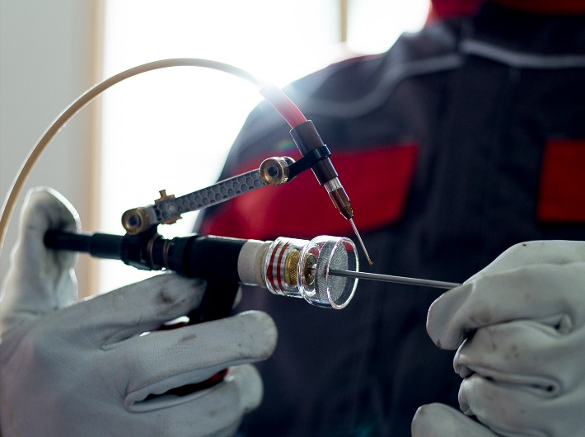
The patented TFC electrode clamping system (Tungsten Fast Clamp) releases and clamps the tungsten electrode at the touch of a button, allowing it to be changed in a matter of seconds.

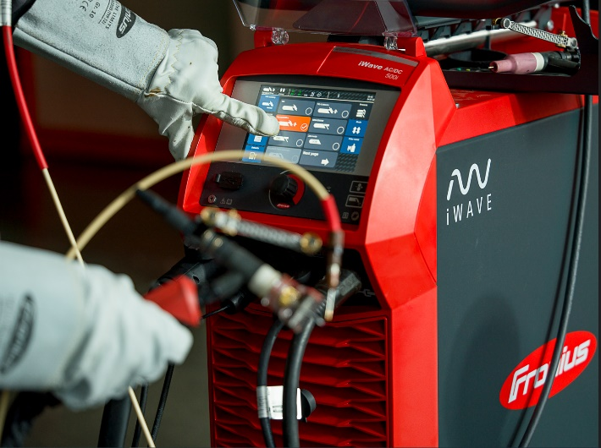
Self-regulating automatic wirefeed via the TIG DynamicWire welding package. Simply download the software and start welding.

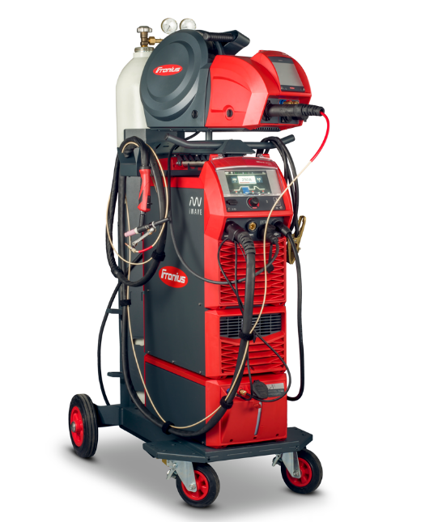
Fronius iWave equipped with all cold-wire components: intelligent SpeedNet-based TIG cold-wire feeder CWF 25i, TIG cold-wire feed system (CW-Feeding), and TFC quick-change electrode system

TIG CW-Feeding: the new cold-wire feed system can be mounted on intelligent TIG welding torches with ease and remains in a stable position after a one-time calibration. If gas nozzles need to be changed, it is simply folded away and then put back again.

Business Unit Perfect Welding
Fronius Perfect Welding is an innovation leader for arc welding and a global market leader for robot-assisted welding. As a systems provider, the Fronius Welding Automation division also implements customized automated complete welding solutions, for the construction of containers or offshore cladding for example. The range is rounded off by power sources for manual applications, welding accessories, and a broad spectrum of services. With more than 1000 sales partners worldwide, Fronius Perfect Welding has great customer proximity.

Fronius International GmbH
Fronius International GmbH is an Austrian company with headquarters in Pettenbach and other sites in Wels, Thalheim, Steinhaus and Sattledt. With 6.100 employees worldwide, the company is active in the fields of welding technology, photovoltaics and battery charging technology. 89% of its products are exported through 36 international Fronius subsidiaries and sales partners/representatives in over 60 countries. With its innovative products and services and 1,366 granted patents, Fronius is the global innovation leader.

For more information, please contact:
United States:
Fronius USA LLC, Ms. Rhonda Zatezalo
6797 Fronius Drive, 46368 Portage, IN
Tel: +1 219 734 5701,
E-Mail: zatezalo.rhonda@fronius.com

United Kingdom:
Fronius UK Ltd; Miss Kim Lee;
Maidstone Road, Kingston, Milton Keynes, MK10 0BD
Phone: +44 1908 512340
E-Mail: lee.kim@fronius.com

Canada:
Fronius Canada Ltd., Mr. Ted Clifford
2875 Argentia Road, Units 3 – 6 Mississauga, ON L5N 8G6
Tel.: +1 905 288 2128,
E-Mail: clifford.ted@fronius.com

South Africa:
Fronius South Africa Pty Ltd; Edric Van der Walt
Dytchley Road, Barbeque Dawns, 1685 Midrand, South Africa
Phone: +27 65 686 8286
E-Mail: VanderWalt.Edric@fronius.com

India:
FRONIUS INDIA PVT. LTD; Geeta Kshirsagar
GAT no 312, Nanekarwadi, Chakan, Taluka- Khed District
Pune 410 501
Phone: +91 9607987766
E-Mail: marketing.india@fronius.com

Fronius International:
Frau Heidemarie Haslbauer Tel.: +43 (664) 88293709,
E-Mail: haslbauer.heidemarie@fronius.com

Please send an author's copy to our agent:
a1kommunikation Schweizer GmbH, Frau Kirsten Ludwig,
Oberdorfstraße 31 A, 70794 Filderstadt, Deutschland
tel.: +49 0 711 9454161-20,
e-mail: kirsten.ludwig@a1kommunikation.de

For more exciting updates, visit our blog at blog.perfectwelding.fronius.com and follow us on Facebook (froniuswelding), Twitter (froniusintweld), LinkedIn (perfect-welding), Instagram (froniuswelding) and YouTube (froniuswelding)!

