PRESS RELEASE

Fronius to host fifth Open House in May

Fronius UK will be opening the doors to its Technology Centre in Milton Keynes to unveil the latest cutting-edge welding technology as it hosts its fifth Open House on 18th and 19th May.
Fronius has put together a wide variety of demonstrations across its range of products, solutions and applications and a programme of talks from specially selected guest speakers and industry partners. The event promises to be informative, hands-on and packed with fun and whether you are looking to review your welding processes, or find out what’s new, this is just the event for you.
This is a real opportunity to explore the world of Fronius and to see up close the most recent advances in welding technology, including the new iWave Multiprocess Pro, launched this January. This machine gives you full freedom to unleash your welding potential. In addition to all the TIG functions, you can weld all MIG/MAG process variants with a single system. If you want to weld faster, with less rework, you can try out the TransSteel Pulse range of MIG/MAG welding machines - and never have problems welding those hard to reach areas again with the new Fronius Flex-Drive. Hear from an expert on the development and possibilities of Wire+Arc Additive Manufacturing (WAAM), plus see some world leading automation and robotic welding solutions.
You can also be one of the first to see the all new Magic Cleaner 150/300. This innovative technology allows optimum reworking of TIG weld seams and stainless steel surfaces in a single step, with minimal impact on the material surface. The electrochemical cleaning devices make it possible to polish welds to a lustrous finish and permanently print logos and serial numbers on workpieces.
Whatever your welding challenge, you can use this day to come and talk to Fronius and see some of the solutions it has on offer, whilst enjoying a schedule of entertainment, a hot lunch and refreshments throughout the day.
“This event provides an ideal opportunity to visit our facility and understand the very latest solutions available on the market”. James Anderson, Director of Welding for Fronius UK comments, “We look forward to welcoming all those involved in welding. I would also encourage anyone currently experiencing welding challenges to come and talk to us about them to see where we could potentially help to improve processes.”
The day will also incorporate the company’s other two business units: Solar Energy and Perfect Charging. With the imminent increase in energy prices, take the opportunity to look at the company’s industry leading solar products and services including its hybrid solar inverter that recently won first place for efficiency in the Energy Storage Inspection 2021 and its new powerful yet robust, project inverter for high yields, the Fronius Tauro.
And if your operation uses any electric forklifts or warehouse trucks you can also find out how unique, intelligent battery chargers from Fronius can reduce your energy costs and CO₂ emissions.
This is just a snippet of what you can expect to see on the day. To find out more, including which industry leading speakers you can expect to hear from, as and when they are announced, visit www.froniusopenhouse.co.uk
Due to the success of its previous Open Houses, the company has made the decision to spread this year’s event across two days to allow everyone the time and space to observe demonstrations safely, provide time to speak to experts and try out products were possible. Fronius UK will welcome guests from 9:30am until 3:30pm on both days.
Register to attend either day at www.froniusopenhouse.co.uk

Characters: 3,656 incl spaces.
Words: 601

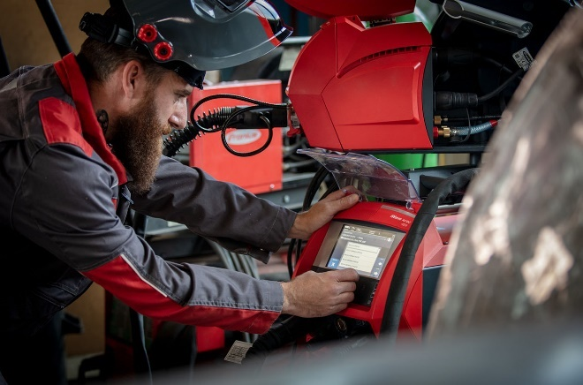
Images:

The Fronius iWave Multiprocess Pro: The combined welding system for every process.
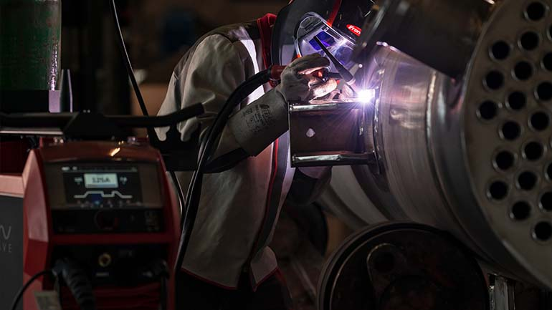
The recently launched iWave from Fronius is an intelligent, high-end series that sets new standards in quality, flexibility and connectivity.
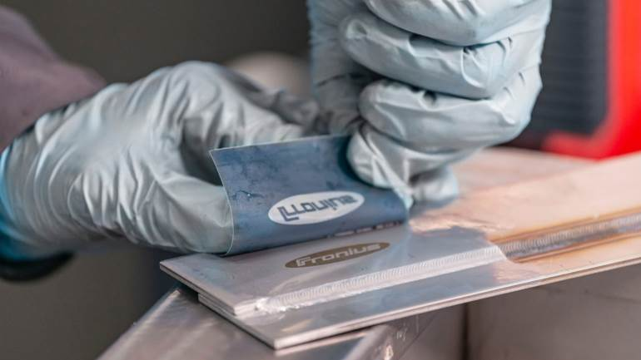
The new generation of the Fronius MagicCleaner series is now available in two sizes and delivers the perfect finish as well as allowing the permanent print of logos or numbers onto surfaces.
Whatever the application Fronius welding machines have all the technology to unleash your welding potential.

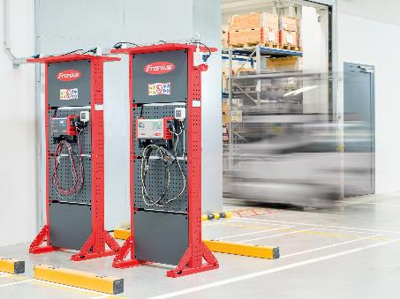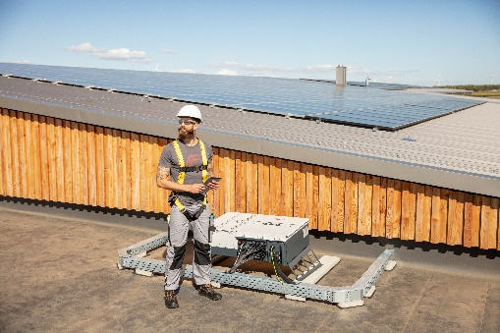
Talk to one of the energy specialists on the day about the savings you could achieve on your energy bills using Solar PV and intelligent battery charging systems for your forklift fleet.

Copyright to photos: Fronius UK Ltd, reproduction free of charge

Fronius UK Ltd
Fronius is an innovation leader for arc and resistance spot welding and a global market leader for robot-assisted welding. As a systems provider, the Fronius Welding Automation division also implements customised automated complete welding solutions, for the construction of containers or offshore cladding for example. The range is rounded off by power sources for manual applications, welding accessories, and a broad spectrum of services.
Operating from their technology centre in Milton Keynes, Fronius UK is one of 30 subsidiaries across the world, with the origins of the family run company being based in Austria. Fronius International GmbH employs over 4,500 people in more than 60 countries. With its innovative products and services and 1,241 granted patents, Fronius is the global innovation leader.
For more information, please contact:
Fronius UK Ltd, Kim Lee,
Maidstone Road, Kingston, Milton Keynes, MK10 0BD
Tel: +44 (1908) 512 340, Fax: +44 (1908) 512 329
E-Mail: lee.kim@fronius.com

