TECHNICAL REPORT

Welding Under Open Skies
Agricultural technology as a welding challenge

Tractors, combine harvesters, and seeders are exposed to the effects of wind, weather, and dirt every single day. Damage and wear are therefore a fact of life, with these machines regularly having to be repaired out in the field – a reality that often presents its own challenges. Reliable, portable, and flexible welding systems are an important tool for farmers and agricultural service technicians.

Welding a clean weld seam in a protected environment with a stable power supply is already a task that requires a great deal of practice. Once you add complicating factors into the mix – such as no electricity supply, barely passable terrain, or a more difficult welding task itself – it becomes necessary for welding systems to meet very special criteria before the repair can have any chance of success. Fronius has several products for just such a scenario, all of which are user-friendly, robust, powerful, and portable. The TransSteel, TransPocket, and AccuPocket are just some examples of these systems.

All three power sources are very intuitive to use and promise a stable arc and reproducible welding results thanks to a digital control system. Software updates mean that users can benefit from new or improved welding processes without having to invest in a brand new device. Protection against spray water (IP 23 protection class) and long service life are further benefits of these models. Fronius tests the robustness of its products in endurance tests that are far more stringent than the requirements stipulated in the relevant standards.

Universal Flexibility

The TransPocket and AccuPocket SMAW and TIG devices are ideal for situations where mobility and flexibility are key. The AccuPocket is perfect for mobile use thanks to a weight of just twenty-four pounds including its lithium-ion battery. When being operated in battery mode, the AccuPocket draws all of the power it needs from its rechargeable battery. A fully charged welding system can weld eight 3.25 mm electrodes or 18 electrodes that are 2.5 mm in diameter. Hybrid mode means the unit can draw power from both the battery and secondary electricity supply at the same time, be that from the grid or a generator. The power reserves in the battery compensate for the voltage fluctuations in the electricity supply and prevent the mains fuse from tripping in the event of a power surge. If desired, power can also be drawn exclusively from the grid. As the AccuPocket’s current consumption is very low, it only needs a smaller – and therefore cheaper – current transformer with two instead of eight kilovolt-amperes.

Where there is no battery available to compensate for the voltage fluctuations, such as with the TransPocket, the Fronius PFC technology (power factor correction) comes into play. PFC technology efficiently uses the available power supply and prevents reactive power, whereby automatic power factor correction models the input current in such a way that it has a virtually perfect sinusoidal wave. By balancing out voltage fluctuations in this way, the PFC technology can guarantee a stable arc. Such fluctuations can occur in generator-powered operation, for example, for which the single-phase welding systems are designed.

Both power sources are programmed with functions such as SoftStart, HotStart, and anti-stick. These stabilize the arc, facilitate ignition, prevent electrode burn-out, and help the mobile technician to produce high-quality welding results.

The All-rounder

For varied welding tasks, multiprocess models such as the TransSteel, which is capable of MIG/MAG, TIG, and SMAW welding, are a perfect choice. A major benefit of single-phase power sources is the wide variety of characteristics that are available, including those for aluminum and copper-silicon alloys. The TransSteel is also fitted with a second gas solenoid valve, which makes it easier to change from a MIG/MAG process to a TIG process. A second advantage is its user-friendliness – the user can be ready to weld in just three steps: enter the filler metal to be welded, the wire diameter, and the gas being used.

Other special features include the TAC function as well as spot and interval welding. The TAC function has been designed for tack welding and uses a pulsed arc to set the two weld pools in motion so that they merge into one. This function is also useful for welding thin sheets without any filler metal. Spot and interval welding is suitable for joining thin sheets too, as the heat input is lower.

Regardless of the power source you choose, they all have to be brought to where they are actually needed. Fronius not only offers the right tool case for the different models, but also the accessories you need to complete a professional job on site.

4809 characters (including spaces)

Captions:

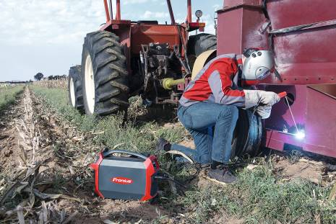

Image 1: At home anywhere: with the AccuPocket, repairs can be completed out in the field.

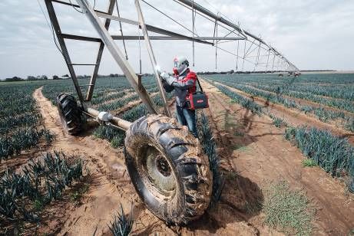

Image 2: The AccuPocket can be carried with ease, weighing just 24 pounds including battery.

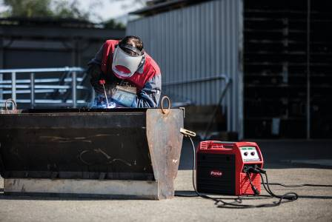

Image 3: With the TransSteel 2200 multiprocess device, agricultural machinery workshops are equipped for every welding task.

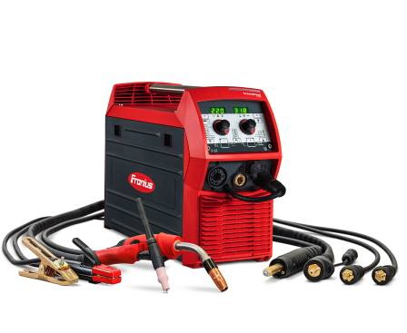
Image 4: Its flexibility makes the TransSteel 2200 a popular all-rounder.

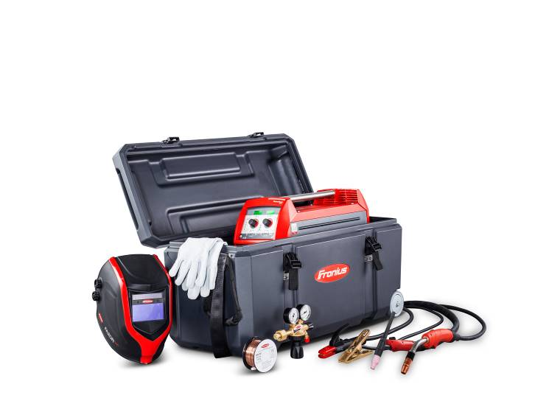
Image 5: The tool cases accommodate both the welding system and its accessories – making sure you have everything to hand wherever the job may take you.

Copyright to photos: Fronius International GmbH, reproduction free of charge

High-resolution images are available to download at the following link:
www.fronius.com/en/welding-technology/infocentre/press

Business Unit Perfect Welding
Fronius Perfect Welding is an innovation leader for arc and resistance spot welding and a global market leader for robot-assisted welding. As a systems provider, the Fronius Welding Automation division also implements customized automated complete welding solutions, for the construction of containers or offshore cladding for example. The range is rounded off by power sources for manual applications, welding accessories, and a broad spectrum of services. With more than 1000 sales partners worldwide, Fronius Perfect Welding has great customer proximity.

Fronius International GmbH
Fronius International GmbH is an Austrian company with headquarters in Pettenbach and other sites in Wels, Thalheim, Steinhaus, and Sattledt. With 4,760 employees worldwide, the company is active in the fields of welding technology, photovoltaics, and battery charging technology. 92% of its products are exported through 30 international Fronius subsidiaries and sales partners/representatives in over 60 countries. With its innovative products and services and 1,253 granted patents, Fronius is the global innovation leader.

This press release and the pictures are available for download from:
www.fronius.com/en/welding-technology/infocentre/press

For more information, please contact
Fronius USA LLC, Ms. Welch Stephanie,
6797 Fronius Drive, 46368 Portage, IN
Tel: +1 (219) 734 5701, E-Mail: welch.stephanie@fronius.com

Please send an author's copy to our agent:
a1kommunikation Schweizer GmbH, FAO Kirsten Ludwig,
Oberdorfstraße 31 A, 70794 Filderstadt, Germany,
Tel.: +49 (0)711 9454161-20, e-mail: Kirsten.Ludwig@a1kommunikation.de

For more exciting updates, visit our blog at blog.perfectwelding.fronius.com and follow us on Facebook (fronius.usa), Twitter (weldfroniususa), LinkedIn (fronius-perfect-welding-usa), Instagram (froniusweldingusa) and YouTube (froniuswelding)!

