TECHNICAL REPORT

Short version

Resource-conserving and flexible:

The Multilock interchangeable welding torch

Flexible, cost-saving, and resource-conserving: the Multilock System from Fronius is a modular torch system for manual TIG and MIG/MAG welding. All the components can be changed from the torch body through the operating elements, enabling the most varied welding applications all with one torch. As a result, savings can be made on acquisition and storage costs, and changeover times reduced.
Author: Christian Aitzetmüller, Welding Torch Product Manager in the Business Unit Perfect Welding at Fronius International GmbH

The Multilock System allows torch bodies of varying lengths and angles to be swapped in next to no time, with over 40 different bodies available for TIG welding, and more than 80 for MIG/MAG. The welder simply presses and turns the torch body to release it from the hosepack: absolutely no tools needed. The new torch body is then locked in place by inserting and rotating it. The system works with both gas-cooled and water-cooled devices, and the body can even be swapped with the hosepack connected. As a result, just one welding torch including hosepack is all that is needed to cover every welding task.

At the same time, the Multilock System from Fronius makes carrying out any welding torch repairs extremely easy. All welding torch components can be replaced without difficulty and spare parts are always available. The parts have a long service life, adding significantly to the sustainability of the system.

1.391 characters (including spaces)

Full version

Resource-conserving and flexible:
The Multilock interchangeable welding torch

Flexible, cost-saving, and resource-conserving: the Multilock System from Fronius is a modular torch system for manual TIG and MIG/MAG welding. All the components can be changed from the torch body through the operating elements, enabling the most varied welding applications all with one torch. As a result, savings can be made on acquisition and storage costs, and changeover times reduced.
Author: Christian Aitzetmüller, Welding Torch Product Manager in the Business Unit Perfect Welding at Fronius International GmbH

The welding torch is the ultimate tool of the trade for a welder. Professional welders can expect to have it in hand all day long, frequently with a need for extended arc times and a high degree of robustness. Whereas, delicate TIG welding work demands featherlight, flexible action from the torch – like an artist guiding a fine brush. Very different demands are placed on the welding torch, depending on the application and part. At the same time, it must be easy and comfortable to use, to suit the personal preferences of the welder.

Costs in time and money for different torch systems
A welder might typically need to move from welding a fillet weld that is easily accessible to – immediately afterwards – welding an angled part. In the past, the question for the welder would often be whether to accept sometimes awkward handling of the welding torch due to the changed component accessibility, or instead to change the entire hosepack to get better weld properties. The first approach means loss of valuable time, while the second means a big investment on the part of the business in acquiring a range of torch systems, all of which come with extra storage and maintenance costs.

The solution: modular system with Multilock

The modular TIG and MIG/MAG welding torches from Fronius provide a solution for varied manual welding challenges and considerably reduce time and effort spent on changing bodies. Torch bodies of varying lengths and angles can now be swapped with ease, so that one welding torch and hosepack form the base for different components such that all welding tasks are covered.

More than 40 different torch bodies are available to choose from for TIG welding and over 80 for MIG/MAG. These also include flexible torch bodies that can be individually bent to shape. The welder simply presses and turns the torch body to release it from the hosepack: absolutely no tools are needed. The new torch body is then locked in place by inserting and rotating it. The system works with both gas-cooled and water-cooled devices.

Durable torch system: reparable and with a long service life

The Fronius Multilock System also proves its worth in the event of a fault: if the hosepack is unaffected, but the torch body is damaged, each component can be independently replaced in next to no time using the Multilock connection. Moreover, spare parts are always available from Fronius. Consequently, a modular torch system not only provides greater flexibility, it also enables resource-conserving and sustainable use of the system.

The extremely long service life of the welding torch components also plays a part here. Fronius designs its wearing parts to enable optimal heat dissipation, significantly extending their life. For instance, Fronius uses a high-quality copper alloy for contact tips, and the outer tubes for the MIG/MAG torch body are made from stainless steel, while the hosepack components also feature high-quality materials.

Welding fume extraction for enhanced workplace safety

When designing the welding torch, the developers at Fronius not only had their sights set on flexibility and ease of repair. Promoting safety for welders was, if anything, an even greater consideration. As a result of their efforts, the modular MIG/MAG welding torch system can now easily be upgraded to function as a fume extraction torch. The FumeEx kit is compatible with all TPS/i-MIG/MAG welding torches from Fronius. It ensures that welding fumes are extracted at the point at which they are generated.

Maximum ease of use and handling for the welder

The developers were also focused on enabling easy, comfortable, and ergonomic handling as far as possible: non-slip, soft components on the handle ensure a secure hold for the new welding torch generation. The ergonomically shaped handle protects the hand musculature from early fatigue. In addition, the ball joint between the torch and the hosepack plus the soft materials used for the hosepack enable effortless, flexible handling.

Welders can also choose between different operating elements depending on personal preference. The Up-Down rocker switch or the rotatable potentiometer make it easy to control the amperage, while the JobMaster function makes it possible to select and activate saved parameters (jobs) on the power source using the welding torch. This function is especially useful if the power source is not within hand reach – such as in the case of repair and installation work. Finally, even the control module can be replaced, should the welding requirements change.

5.091 characters (including spaces)

Navigation Title: Technical report: Modular welding torch system
Display Name: technical-report-modular-manual-welding-torch
Meta title: Resource-conserving and flexible: the modular manual welding torch
Meta description: Manual welding torch from Fronius that reduces acquisition and storage costs: all components, such as the torch body and controls, can simply be swapped as and when required.

Captions:

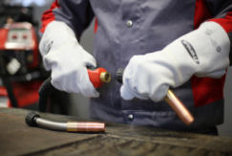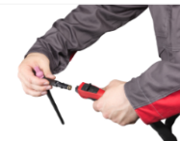
Image 1 & 2: Insert and rotate – swapping the torch body is quick and straightforward with the Multilock System.

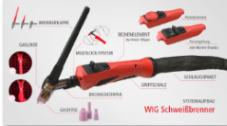
Image 3: The modular TIG welding torch concept from Fronius encompasses various operating elements, torch bodies, torch caps, gas nozzles, gas lenses, and even different handles.

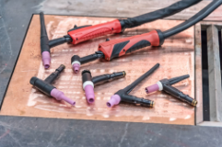
Image 4: The wide choice of torch bodies (shown here for TIG) ensures ideal accessibility for all part geometries.

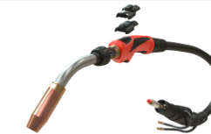
Image 5: The torch body and operating elements can be swapped on the modular MIG/MAG welding torch system – all that is needed for the installation of a Multilock welding torch is a Multilock shielding gas hosepack.

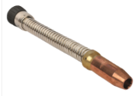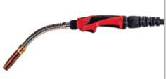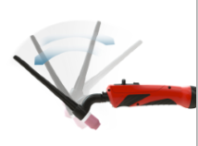
Image 6 & 7 & 8: Fronius supplies flexible torch bodies for both MIG/MAG and TIG that can be individually bent to shape, enabling their use for situations where part accessibility is particularly challenging.

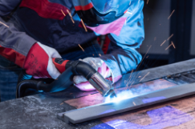
Image 9: The FumeEx extraction kit can be fitted to any TPS/i MIG/MAG welding torch. It acts by extracting the welding fumes immediately behind the gas nozzle – without affecting the gas shroud around the weld pool.

Image 10: Author: Christian Aitzetmüller, Welding Torch Product Manager in the Business Unit Perfect Welding at Fronius International GmbH

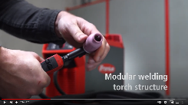
Video 1: https://www.youtube.com/watch?v=AGaRUbXyxEg
Swapping a torch body using the Multilock System – example showing TIG welding with MagicWave and TransTig

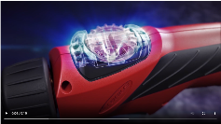
Video 2: https://blog.perfectwelding.fronius.com/en/mig-mag-welding-torches-making-the-right-choice/
Various control systems with modular MIG/MAG manual welding torch

Copyright to photos: Fronius International GmbH, reproduction free of charge

High-resolution images are available to download at the following link:
www.fronius.com/en/welding-technology/info-centre/press/technical-article-manual-welding-torches

Business Unit Perfect Welding
Fronius Perfect Welding is an innovation leader for arc welding and a global market leader for robot-assisted welding. As a systems provider, the Fronius Welding Automation division also implements customized automated complete welding solutions, for the construction of containers or offshore cladding for example. The range is rounded off by power sources for manual applications, welding accessories, and a broad spectrum of services. With more than 1000 sales partners worldwide, Fronius Perfect Welding has great customer proximity.

Fronius International GmbH
Fronius International GmbH is an Austrian company with headquarters in Pettenbach and other sites in Wels, Thalheim, Steinhaus and Sattledt. With 5,440 employees worldwide, the company is active in the fields of welding technology, photovoltaics and battery charging technology. 93% of its products are exported through 34 international Fronius subsidiaries and sales partners/representatives in over 60 countries. With its innovative products and services and 1.264 granted patents, Fronius is the global innovation leader.

For more information, please contact:
Fronius USA LLC, Ms. Welch Stephanie,
6797 Fronius Drive, 46368 Portage, IN
Tel: +1 (219) 734 5701, E-Mail: welch.stephanie@fronius.com

Please send an author's copy to our agent:
a1kommunikation Schweizer GmbH, FAO Kirsten Ludwig,
Oberdorfstraße 31 A, 70794 Filderstadt, Germany,
Tel.: +49 (0)711 9454161-20, e-mail: Kirsten.Ludwig@a1kommunikation.de

For more exciting updates, visit our blog at blog.perfectwelding.fronius.com and follow us on Facebook (froniuswelding), Twitter (froniusintweld), LinkedIn (perfect-welding), Instagram (froniuswelding) and YouTube (froniuswelding)!

