# PRESS RELEASE

**Vizor Connect welding helmet from Fronius:**

**Intelligent occupational safety for maximum comfort**

**The Vizor Connect is the world’s first welding helmet that communicates with a power source via Bluetooth. This means that it darkens prior to ignition rather than waiting until the arc is lit. The helmet also eliminates the problem of interference from external light and reliably darkens even in demanding welding situations. It therefore ensures a higher degree of both safety and comfort.**

Using Fronius PreTrigger technology, the power source sends a signal to the welding helmet via Bluetooth as soon as the user presses the On button on the welding torch. The helmet therefore darkens before the arc is ignited. This protects users against the abrupt flash of light that would previously appear before the helmet darkened. This completely protects the welder’s eyes from welding light and reduces tiredness.

The auto-darkening filter cartridge remains in place even at the lowest currents and if the arc is concealed and in constrained positions, as long as the arc is burning. This is because the helmet reliably responds to the signal sent by the connected power source. This improves occupational safety for the welder. The level of protection applicable to the welding process is automatically adjusted between DIN 5 and DIN 12. The darkness level is therefore perfectly adapted to the intensity of the arc at all times. The welder also has the option of switching to manual mode and infinitely adjusting the darkness as required.

**A clear view at all times**

A further advantage is that the Vizor Connect eliminates the problem of interference from external light. Conventional welding helmets sometimes darken at inappropriate times as a result of light reflections, warning lights, or external welding light. Not the Vizor Connect. The helmet provides ideal protection during activities before and after welding, including grinding. When the welder disconnects the Bluetooth connection between the helmet and the power source, the Vizor Connect acts like a conventional protective helmet and darkens in the presence of light sources as of a certain intensity.

When the helmet is not darkened, it provides a clear view with a brightness level of 2.5 as well as real color perception thanks to a specially developed UV and infrared filter. The auto-darkening filter cartridge with nose cut-out gives the welder an unobstructed line of sight and makes the helmet extremely comfortable to wear. The special shape increases the field of view up to six times and reduces the weight of the helmet.

*2,588 characters (including spaces)*

*Zeichen: 2.551 inklusive Leerzeichen*

**Captions:**

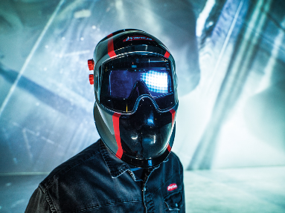

**Photo 1**: The welding helmet is an important part of personal protective equipment, it protects the eyes and face of the welder from the harmful UV radiation.

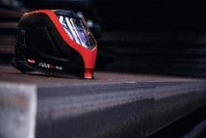

**Photo 2**: The Vizor Connect extends the helmet range from Fronius and sets a new standard in smart protective equipment. (Shown in this picture: the helmet model FAZOR 1000 Plus)

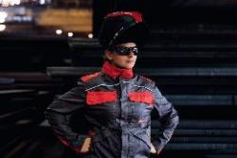

**Photo 3:** Especially in challenging situations the welder has to rely 100 percent on his protective gear. (Shown in this picture: the helmet model FAZOR 1000 Plus)

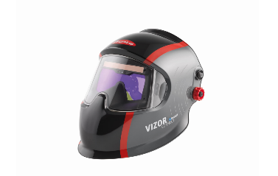

**Photo 4:** The modern design of the Vizor Connect from Fronius reflects its high-tech functionality. The nose cut-out gives the welder an unobstructed line of sight.

Copyright to photos: Fronius International GmbH, reproduction free of charge

**Business Unit Perfect Welding**

Fronius Perfect Welding is an innovation leader for arc and resistance spot welding and a global market leader for robot-assisted welding. As a systems provider, the Fronius Welding Automation division also implements customized automated complete welding solutions, for the construction of containers or offshore cladding for example. The range is rounded off by power sources for manual applications, welding accessories, and a broad spectrum of services. With more than 1000 sales partners worldwide, Fronius Perfect Welding has great customer proximity.

**Fronius International GmbH**

Fronius International GmbH is an Austrian company with headquarters in Pettenbach and other sites in Wels, Thalheim, Steinhaus and Sattledt. With 4,550 employees worldwide, the company is active in the fields of welding technology, photovoltaics and battery charging technology. 91% of its products are exported through 30 international Fronius subsidiaries and sales partners/representatives in over 60 countries. With its innovative products and services and 1,241 granted patents, Fronius is the global innovation leader.

This press release, and the pictures, are available for download from:

[www.fronius.com/en/welding-technology/infocentre/press](http://www.fronius.com/en/welding-technology/infocentre/press)

**For more information, please contact:**

Fronius International GmbH, Communication / Public Relations, Leonie DOPPLER (Ms.),

Froniusplatz 1, A 4600 Wels, Austria, Phone +43 (7242) 241-3884,

Fax: +43 (7242) 241-954938, E-Mail: [doppler.leonie@fronius.com](mailto:doppler.leonie@fronius.com)

**Please send an author's copy to our agent:**

a1kommunikation Schweizer GmbH, FAO Kirsten Ludwig,

Oberdorfstraße 31 A, 70794 Filderstadt, Germany,

Tel.: +49 (0)711 9454161-20, e-mail: [Kirsten.Ludwig@a1kommunikation.de](mailto:Kirsten.Ludwig@a1kommunikation.de)

Fotos: Fronius International GmbH, Abdruck honorarfrei

**Business Unit Perfect Welding**

Fronius Perfect Welding ist Innovationsführer für Lichtbogen- sowie Widerstandspunktschweißen und globaler Marktführer für robotergestütztes Schweißen. Als Systemanbieter realisiert der Bereich Fronius Welding Automation außerdem kundenspezifische automatisierte Schweiß-Komplettlösungen, etwa im Behälterbau oder für Plattierungen im Offshore-Bereich. Stromquellen für manuelle Anwendungen, Schweißzubehör und ein breites Dienstleistungs-Spektrum ergänzen das Portfolio. Mit mehr als 1.000 Vertriebspartnern weltweit ist Fronius Perfect Welding besonders nah am Kunden.

**Fronius International GmbH**

Fronius International ist ein österreichisches Unternehmen mit Sitz in Pettenbach und weiteren Standorten in Wels, Thalheim, Steinhaus und Sattledt. Die Firma ist mit 4.550 Mitarbeitern weltweit in den Bereichen Schweißtechnik, Photovoltaik und Batterieladetechnik tätig. Mit 30 internationalen Gesellschaften sowie Vertriebspartnern und Repräsentanten in mehr als 60 Ländern erzielt Fronius einen Exportanteil von 91 Prozent. Fortschrittliche Produkte, umfangreiche Dienstleistungen sowie 1.241 erteilte Patente machen Fronius zum Innovationsführer am Weltmarkt.

Diese Presseinformation sowie die Bilder stehen für Sie zum Download im Internet zur Verfügung:

[www.fronius.com/de/schweisstechnik/infocenter/presse](http://www.fronius.com/de/schweisstechnik/infocenter/presse)

**Für weitere Informationen wenden Sie sich bitte an:**

Deutschland:

Frau Annette Orth, Tel.: +49 (6655) 91694-402,

E-Mail: [orth.annette@fronius.com](mailto:orth.annette@fronius.com)

Österreich:  
Frau Ilse Mayrhofer, Tel. +43(0)7242/241-4015,

E-Mail: [mayrhofer.ilse@fronius.com](mailto:mayrhofer.ilse@fronius.com)

Schweiz:  
Frau Monique INDERBITZIN, Tel. +41 (79) 945 76 20,   
E-Mail: inderbitzin.monique@fronius.com

**Bitte senden Sie ein Belegexemplar an unsere Agentur:**

a1kommunikation Schweizer GmbH, Frau Kirsten Ludwig,

Oberdorfstraße 31 A, D – 70794 Filderstadt,

Tel.: +49 (0)711 9454161-20, E-Mail: [Kirsten.Ludwig@a1kommunikation.de](mailto:Kirsten.Ludwig@a1kommunikation.de)